Piezoelectric sensors to measure the speed of vehicles

By the CoEP Astronomy Club



As a part of TECHNOCRAFT 2009

ACKNOWLEDGEMENTS

The COEP Astronomy Club would like to express their sincere thanks to the following people for their constant support and encouragement:

- Dr. M.Y.Khaladkar – Head of Department, Applied Science
- The Staff at the Production Engineering Workshop

It was because of their timely guidance that this project has taken its present shape.

We would also like to thank Mr. Rahul Terdalkar, our Alumni Association Guide for showing faith in our idea and for funding this project.

THE TEAM

Name | Year | Branch
Avnish Dhongde | B. Tech | Mechanical
Bhushan Bhalerao | F. Y. B. Tech | Production
Nishant Phatangare | F.Y. B. Tech | E & T C
Samiksha Chandak | F.Y. B. Tech | E & T C
Gautam Akiwate | F.Y. B. Tech | Information Technology
Sneha Shirsat | F.Y. B. Tech | Information Technology
Neha Kulkarni | S. Y. B. Tech | Computer
Varad Deshmukh | S. Y. B. Tech | Computer
Ajinkya Rao | S. Y. B. Tech | E & T C
Akash Ambulkar | S. Y. B. Tech | E & T C
Mukesh Angrakh | S. Y. B. Tech | E & T C
Shailesh Wankhede | S. Y. B. Tech | E & T C
Padmaja Kulkarni | S. Y. B. Tech | Electrical
Priya Ganadas | S. Y. B. Tech | Electrical
Nishchay Mhatre | S. Y. B. Tech | Information Technology
Aadinath Harihar | S. Y. B. Tech | Mechanical
Poonam Rane | S. Y. B. Tech | Mechanical
Abhishek Bawiskar | T. Y. B. Tech | Civil
Jayesh Mutha | T. Y. B. Tech | Production
Mohit Karve | T. Y. B. Tech | Production

TABLE OF CONTENTS

ART. | SECTION. | TOPIC | PAGE NO.
1 | [1] | Introduction | 4
 | [2] | Need for the system | 5
2 |  | Design Considerations | 6
 | [1] | Mechanical | 6
[2.1.1] Ceramic piezoelectric cells
[2.1.2] Copper plate as one electrode
[2.1.3] Galvanised iron sheet
[2.1.4] Acrylic sheet

 | [2] | Electronics | 8
[2.2.1] Block Diagram
[2.2.2.1] Amplification
[2.2.2.2] Pulse modulation
[2.2.2.3] Triggering
[2.2.2.4] Time Calculation
[2.2.2.5] Microcontroller

3 |  | Testing and Fabrication | 11
4 |  | Costing of the model | 13
5 | [1] | Looking Ahead-Future Implementation | 14
[5.1.1] Mechanical Design Parameters
[5.1.1.1] Useful cycles
[5.1.1.2] Mechanical wear and fatigue
[5.1.1.3] Seasonal stability
[5.1.1.4] Maintenance and service
[5.1.1.5] Cost

[1.1] INTRODUCTION:

Piezoelectric crystals have been known for a long time to generate electricity when impacted. Attempts have been made, with varying degrees of success, to harness this property of piezoelectric crystals to generate electricity. While the electrical generation efficiency of these crystals varies with material, the overall efficiency of the system is quite low. Another practical problem of piezoelectric electricity generation is that while high voltages can be developed with ease, it is hard to generate significant currents. A single piezoelectric cell may generate currents of the order of micro amperes, or even nano amperes.
Here, an effort is made to harness the voltages generated by piezoelectric crystals to measure speeds of vehicles. The concept itself is quite simple.
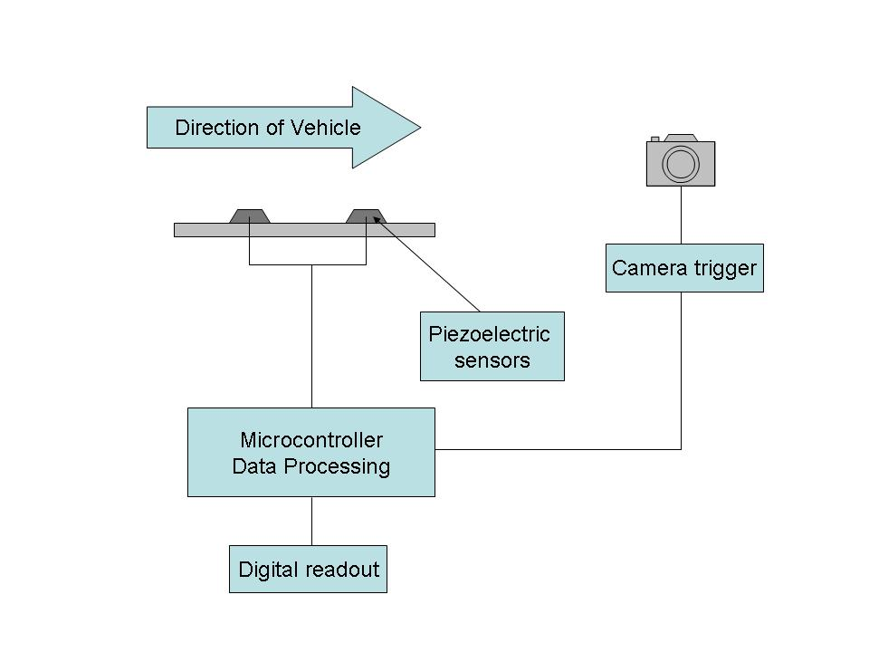
Block Diagram of system

Two piezoelectric arrays are placed on the road surface at a fixed distance. When a vehicle passes over this pair of arrays, a voltage is generated by the crystals. The pulses generated by the sensor array are measured by an electronic circuit and the time difference between them is also noted. Since the time difference and the distance are exactly known, the speed of the vehicle can be calculated.

The application of this system is for checking speed limit violations on public roads. If a vehicle passing over the sensor system is found to be over speeding, the system sends a pulse to a camera, triggering it and taking a photograph of the vehicle with its number plate. This photograph is stored along with other important parameters, such as time, date, place and the measured speed. With the combination of this data it is possible to bring offenders to justice.

[1.2] NEED FOR THE SYSTEM:

India is progressing fast toward the mantle of ‘developed country’. Integral parts of this progress are higher earnings, better cars, and better roads. As faster vehicles and better roads spread across our country, it becomes important to maintain a degree of control over vehicular speeds with an eye towards road safety. In developed countries, this control is exercised by means of radar/ laser based speed guns that measure speeds of vehicles based by measuring the Doppler shift of reflected radiation.

In recent times, this technology has started gaining acceptance in Indian police forces as well. A major stumbling block is the prohibitive cost involved in purchasing radar/laser based speed guns. Radar based speed guns start from a price of around $250. Laser based guns are even more expensive, hovering around the $2000 mark. When this technology is imported, taxation and other overheads take these already high prices to soaring levels. A laser speed gun recently procured by the Pune Police is estimated to have cost them approximately INR 3,00,000. That is a staggering 188% more than the American price of the speed gun!

From the outset, the idea was to develop a robust and inexpensive speed sensor for use in India and abroad. This indigenously built sensor will be able to interface with a camera and will therefore be able to perform all the functions that the laser speed gun (or even the radar speed gun) can perform, and at a small fraction of the cost.

The current model performs to the above expectations. It is extremely inexpensive to build and of strong construction. A number of tests were conducted to ensure that the piezoelectric cells can provide sufficient response to vehicles passing over it at different speeds. The tests have been successful and are discussed in detail in another part of this report.

[2] DESIGN CONSIDERATIONS

[2.1] MECHANICAL:

This piezoelectric speed sensor will be subject to large loads during its operation life due to the fact that it will be set up on highways and major roads. It will be exposed to harsh tropical weather conditions. In this context, it was necessary to make the piezo-array as robust as possible. Many materials were discussed with respect to properties and prices. Keeping in mind the functional requirements of this model, the following components were selected:

- Ceramic piezoelectric cells
- Copper plate as one electrode
- Galvanised iron sheet
- Acrylic sheet

Before the components are discussed, it should be noted that this model is being build for one half of a traffic lane. This construction will not be used as is on the final road worthy sensor. The properties and materials for the final road worthy sensors are discussed in detail later.

[2.1.1] Ceramic cells
Ceramic piezoelectric cells were selected due to easy availability and low cost. The cells are of 4cm diameter, with electrodes on both sides of the cell.

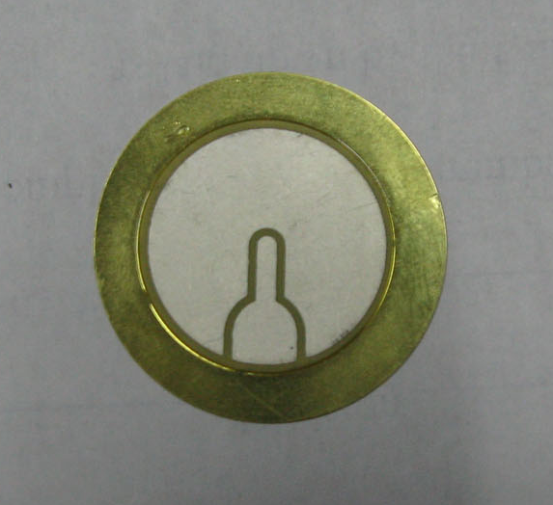
Piezoelectric cell

[2.1.2] Copper Plate
A Copper plate is used as the base on which the piezoelectric cells are mounted. The copper plate not only acts as the mounting base, but also a common electrode for all the crystals. The second electrode of the crystal is drawn out by a wire- the cells form a parallel array.

[2.1.3] Galvanised Iron Sheet
This sheet acts as a protective shield over the entire assembly and also spreads load more uniformly across the cell. The crystal has particular zones where impact produces the maximum voltage. Running a vehicle over exposed piezoelectric crystals not only leaves the crystals susceptible to damage, but also leaves the possibility that the tyre may miss the maximum voltage zone completely. In order to prevent this from happening, the GI sheet was used.

[2.1.4] Acrylic Sheet
An acrylic sheet is used as the base of the entire assembly. The purpose of the acrylic sheet is to provide a flat base to the piezo-array. The piezoelectric cells are found to be susceptible to shear. Therefore this precaution is necessary. Further, due to the critical nature of the distance between the two arrays, the acrylic sheet also ensures that the distance remains constant.

The array is thus as below:

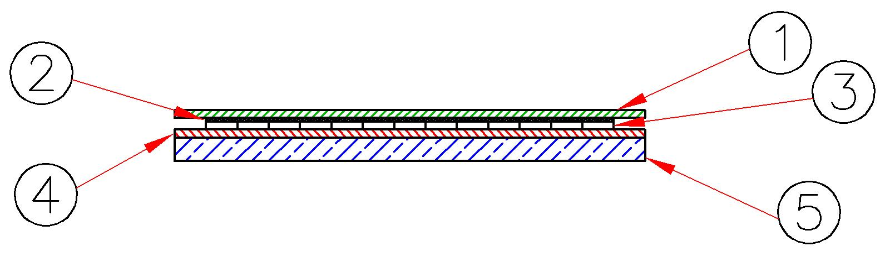
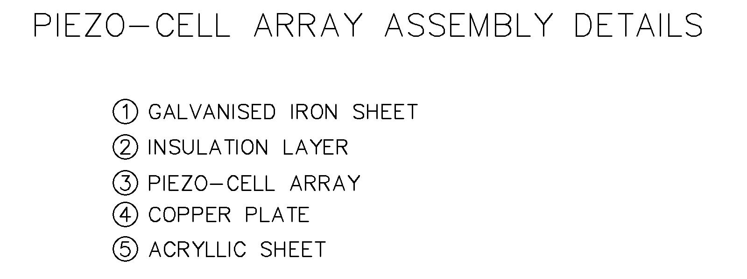

LAYOUT
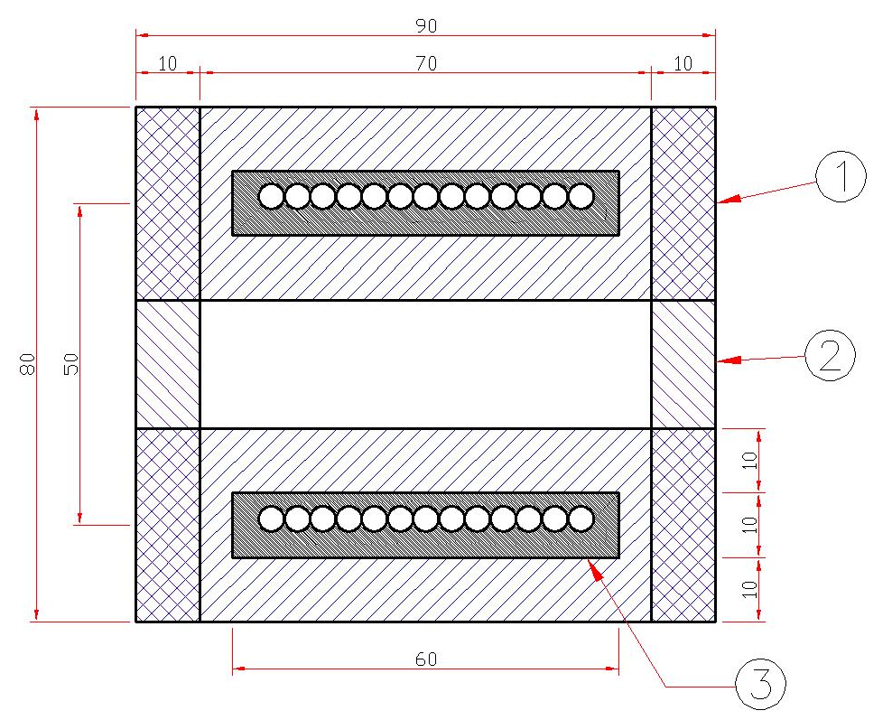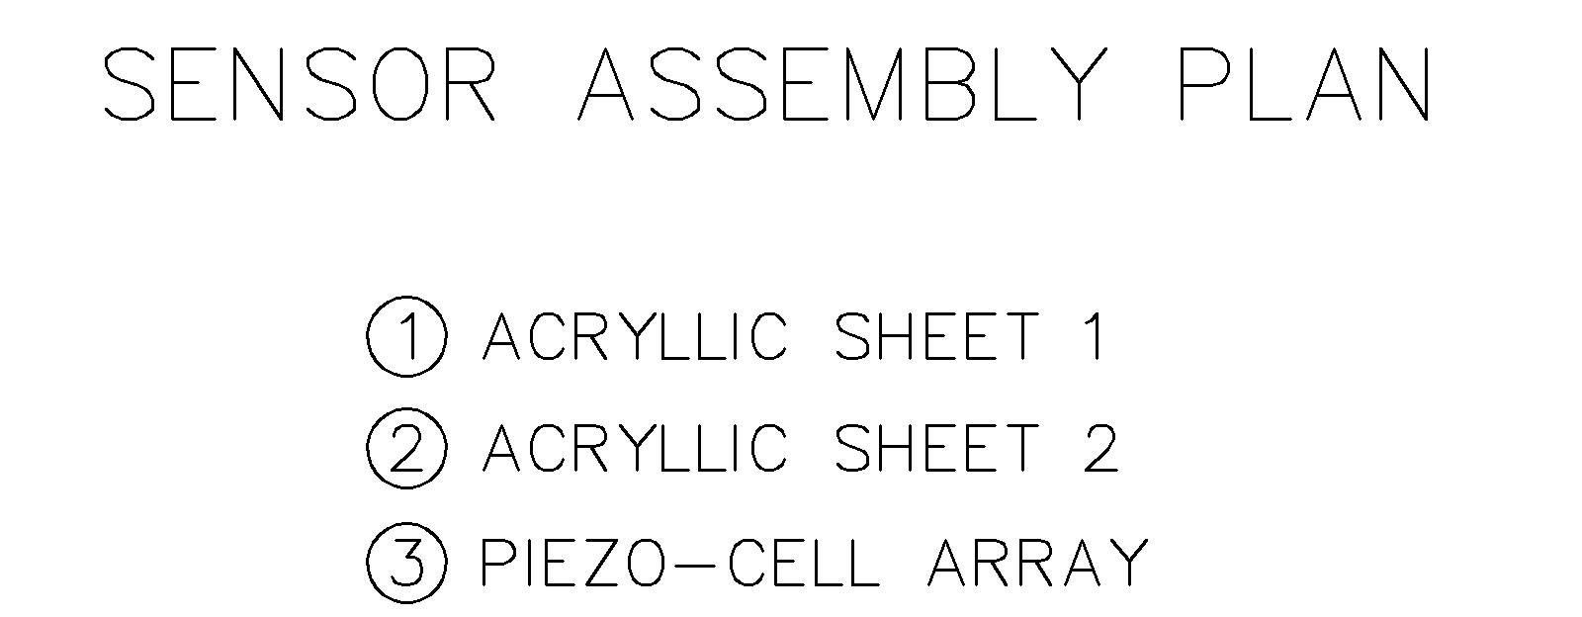
[2.2] ELECTRONICS:

ANALYSE Circuit- The Electronics and Programming of Sensing Elements

The principle of working of the system is to find the time required by the vehicle to cover a specified distance. Hence finding the velocity! The Analyse Circuit converts the time between consecutive impulses recorded at any sensor array into the average speed of the vehicle. This basically requires tapping the incoming pulses from the Piezo sensors.

[2.2.1] Block Diagram:
Time computing- There are two panels of piezosensors at a distance ‘d’ from each other. When the vehicle passes over the first panel the circuit is triggered and the microcontroller starts counting. When the vehicle passes over the second panel the circuit is deactivated and the microcontroller stops counting. The time interval ‘T’ is
hence measured.
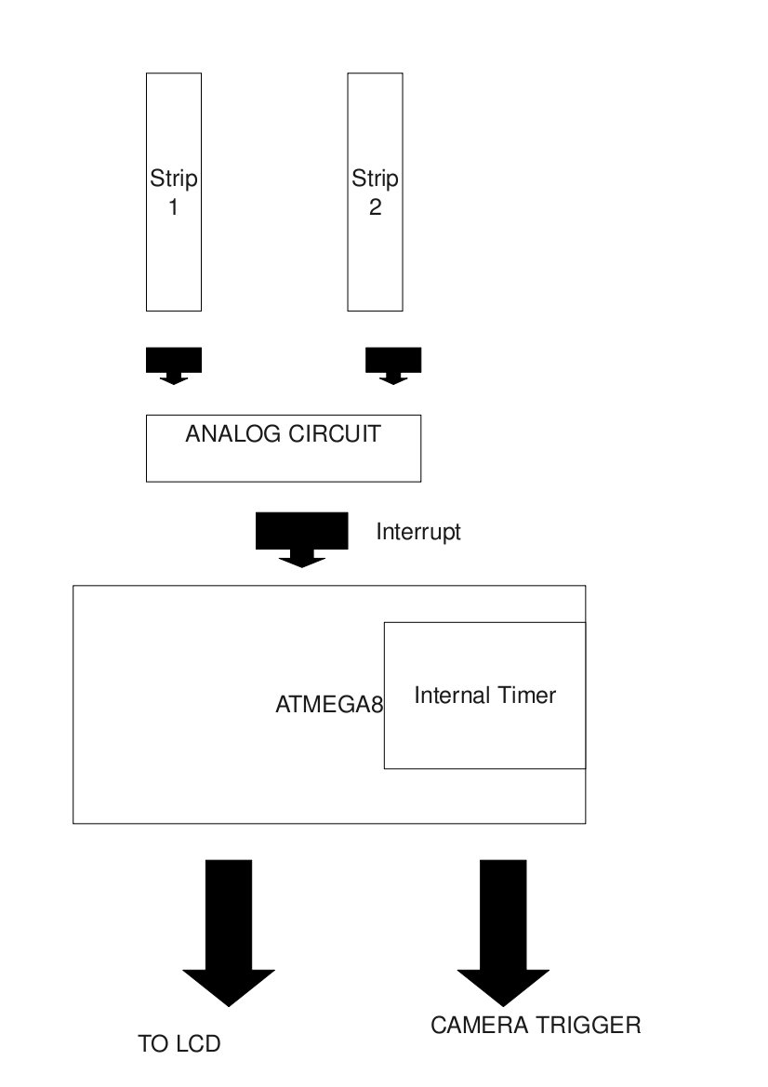
Note: This triggering and deactivating of the circuit takes place in steps. This is necessary in the view of the fact that though the incoming voltage pulse is significant the current is of the order of nanoamperes which is too small an amount to drive any of the circuits.
[2.2.2.1] Stage 1: Amplification
This stage is set up for current gain. It is used to convert the nanomperes current into a decent milliamp current which can drive the further circuits. For this we use the Common Collector Mode. The CC mode of the amplifier is used when only current gain is required. Moreover, we do not require voltage amplification as the normal output voltage is pretty significant and more amplification could damage the circuit.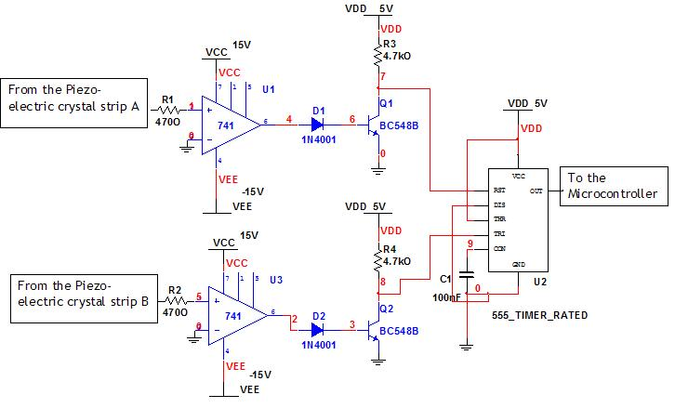

[2.2.2.2]Stage 2: Pulse Modulation
This stage aims for creating order in the incoming pulse. The incoming pulse from the piezo sensors is erratic and undulating which is not convenient to utilize. Also the changing voltage may pose a threat to the circuitry. So an Op-Amp with a high gain is used so that incoming pulses are brought to the V_{sat} of the Op-Amp. This converts the erratic pulse into a brief but clear pulse.
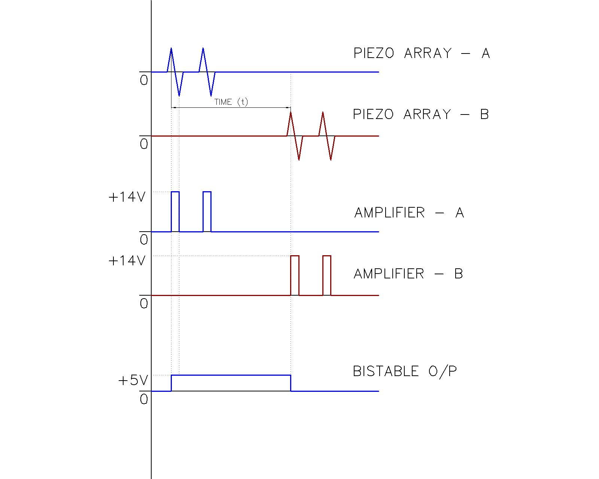

[2.2.2.3] Stage3: Circuit Triggering
This is the stage that actually triggers the circuit. A switching action is required which is provided by a transistor. For a transistor in the Saturation region, the collector to emitter voltage (V_{CE}) is zero. Maximum current flows through the collector terminal. The transistor is said to be in ON state. However as the emitter-collector is for all practical reasons shorted, the output is at logic 0. Now when we give 0 volts at the base there is no I_{b} and since I_{c}=BI_{b} , the current Ic is also 0. So the entire of Vcc appears across the collector-emitter terminals. Although the transistor is said to be OFF the collector-emitter voltage is high and hence the output is at logic 1.

[2.2.2.4] Stage 4: Time calculations
This is the stage that actually gives us the time T in a pulse where the T_{ON} is equal to the time T. This stage incorporates a Bistable Multivibrator made using IC 555. The advantage of using an IC555 is that it has a separate trigger and reset pin. Also once it is set to ‘high’, nothing except the ‘reset’ can bring it back to logic 0. This basically solves our problem of multiple pulses being generated at impact. When Stage 2 gives a brief pulse to Stage 3, the voltage there drops to 0 (it is grounded) - hence triggering the IC 555. The second panel is connected to another separate circuit similar to Stages 1 2 and 3 which however works to deactivate the circuit. Thus when the vehicle runs over the second panel the IC555 is deactivated and the output goes low. The important thing to note here is that the time for which output was high is exactly equal to the time ‘T’ required by the vehicle to cover the distance ‘d’. Any errors caused by the delay of the circuit components gets cancelled out.

[2.2.2.5] Stage 5: Microcontroller
This is the microcontroller unit and also the last stage of the analysis circuit. Here the microcontroller starts counting when the IC555 output goes high and stops when it goes low- effectively measuring the time T. The microcontroller then divides the distance d by the time T to obtain the speed of the vehicle. If the speed is greater than a preset value(inclusive of a 5% tolerance) it triggers a camera circuit which takes the snap of the offender.

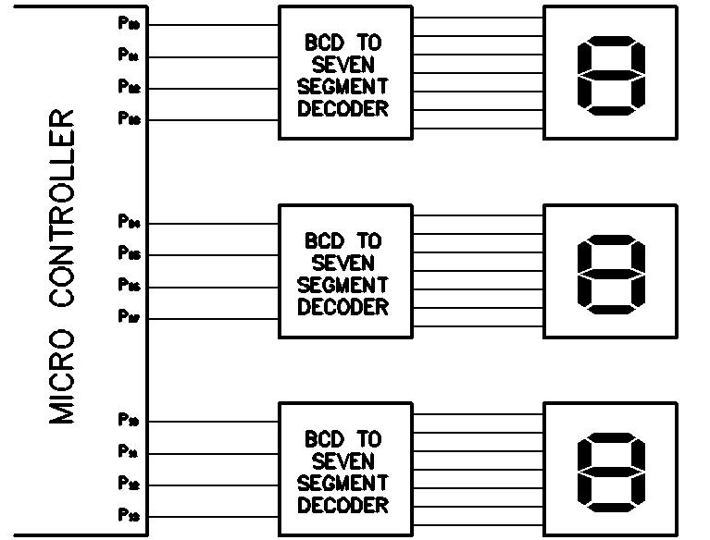
[3] TESTING AND FABRICATION

The fabricated model has been extensively tested on a variety of loading conditions and speeds. All such tests have been successful and a graphical summary of the same is presented below.

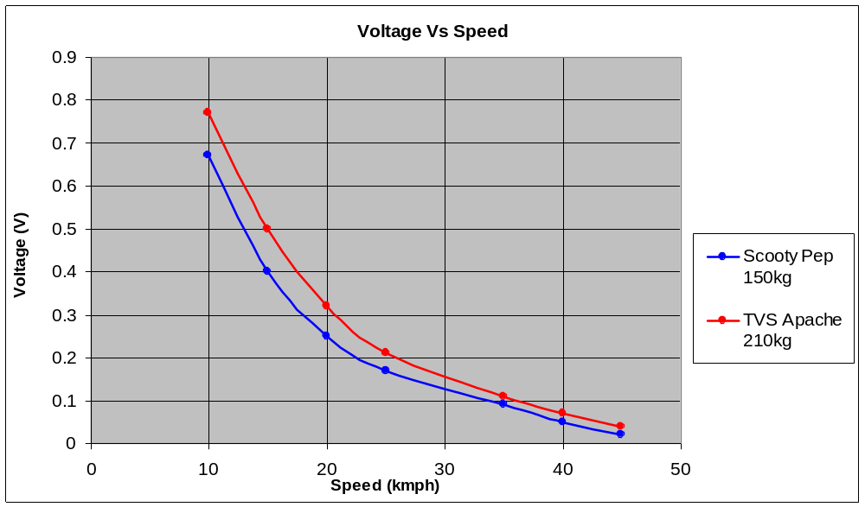

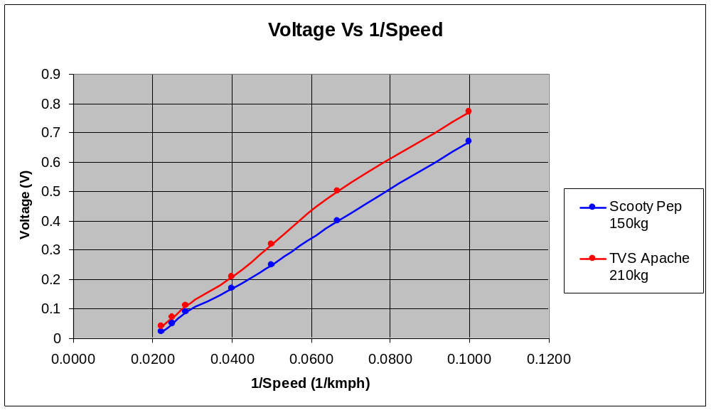

The above graphs have been plotted considering actual readings obtained during testing. The highly regular features of the graph can be used in further modelling/ design when customised units need to be produced for actual highway applications.

A more accurate sketch of the same using computerised trend setting is shown below:

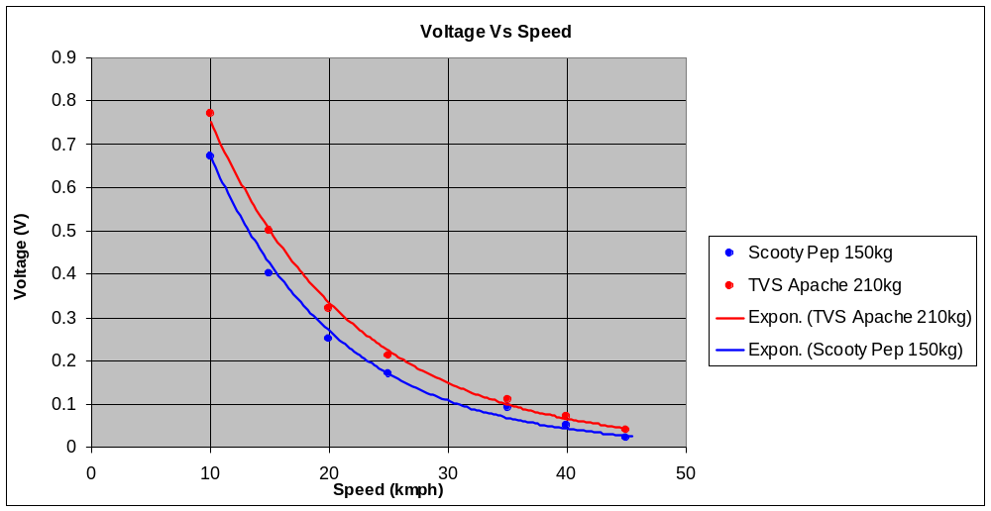
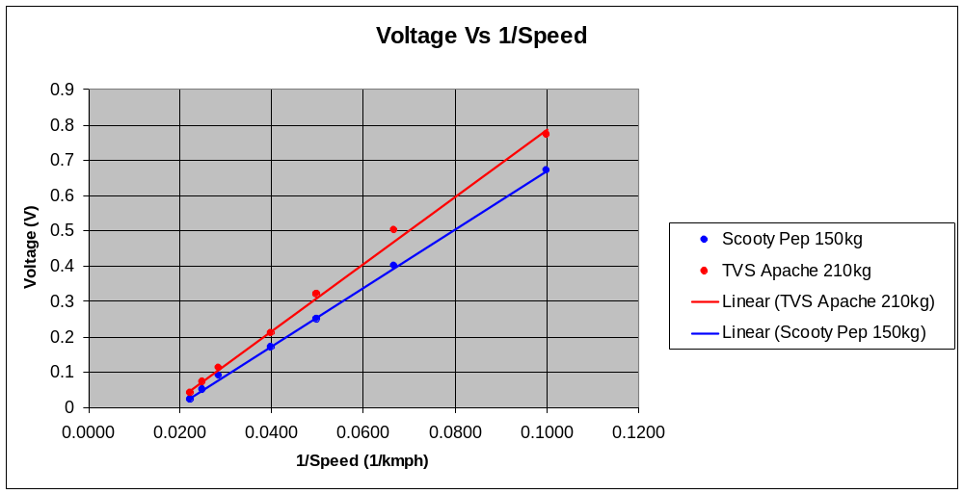

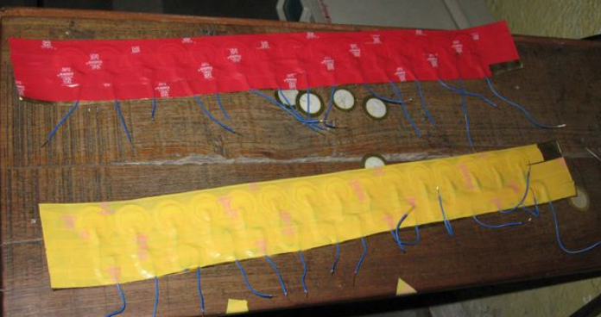
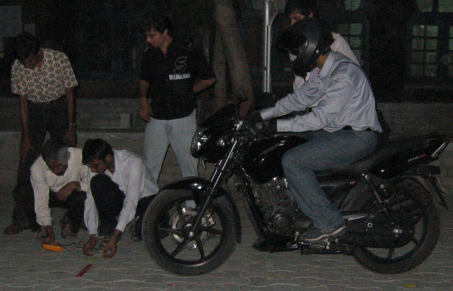 The sensor arrays for the model post insulation Testing of a prototype

[4] COSTING

Sr. | COMPONENT | QTY | COST (INR) | TOTAL (INR)
1 | Piezoelectric Sensor Array | 2 | 70 | 140
2 | Acrylic Base | 1 | 300 | 300
3 | Electronic Components | 1 | 400 | 400
 |  |  | TOTAL | 840
 | DETAILS
1 | PIEZOELECTRIC SENSOR ARRAY
Copper plate base |  | 1 | 40 | 40
Ceramic Piezoelectric crystals |  | 15 | 1 | 15
Single core wire (0.5 metres) |  | 0.5 | 7 | 3.5
Electrical insulation tape(2m) |  | 2 | 1 | 2
GI Sheet |  | 1 | 9.5 | 9.5
 |  |  | SUBTOTAL | 70
2 | ELECTRONIC COMPONENTS
Input amplification circuit |  | 1 | 25 | 25
Microcontroller Atmega 8 |  | 1 | 80 | 80
Printed Circuit Board |  | 1 | 50 | 50
7 Segment display |  | 3 | 35 | 105
Single core wire (5m) |  | 5 | 7 | 35
7 Segment display controller |  | 3 | 35 | 105
 |  |  | SUBTOTAL | 400

[5] LOOKING AHEAD- FUTURE IMPLEMENTATIONS

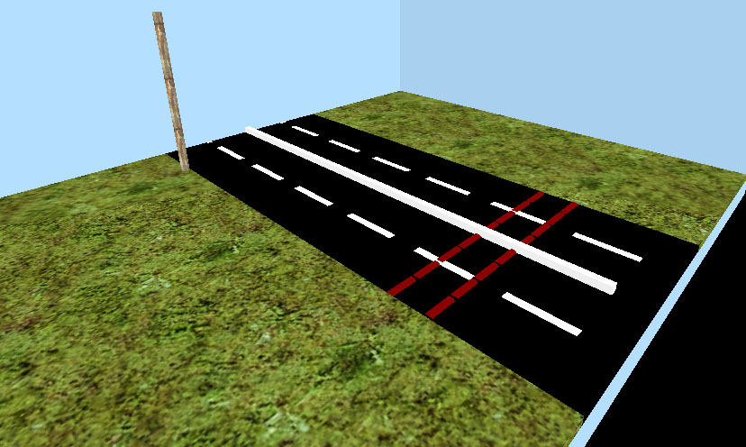

[5.1] ON ROAD VIABILITY:

The setup of the piezoelectric cells has proved to be robust enough during initial testing on a smaller scale. However the real test is the actual highways when the loading of the sensor is much higher and the frequency of impact many times greater. In principle there is no difference in mode of operation of the sensor units but reliability issues must be addressed on priority.

[5.1.1] Mechanical Design Parameters:

The main considerations taken into account during the design for on-road use are:

[5.1.1.1] Piezoelectric cell – useful cycles
Any piezoelectric cell has a specified number of useful cycles- the number of times it may be excited by vibration to generate an output signal voltage. For the cells used on our scale model, this figure is 4000 cycles. But such a number is grossly insufficient considering the recent nature of traffic on highways. What will be employed during actual production is a much longer lasting, heavy duty piezo cell- ideally designed to withstand 100 million impacts and more.

[5.1.1.2] Ability to withstand mechanical wear and fatigue due to repeated impacts
The inherent design on the cell must allow for repeated bruising due to contact with fast moving wheels of vehicles without compromise on functionality. For this purpose the mounting surface of the copper plate as well as the protective surface (that will shield the of the array of cells from the road directly) must have sufficient hardness and a small amount of elastic deformability. This ensures contact every time and at the same time enhances the life of the cell. P V C based Filler free Vinyl Alloy is the chemical base from which thermoplastic sheets can be extruded. Their flexibility is utilized in accommodating the entire array mounted on copper in an encapsulated form. Two leads emerge as the signal carriers from the two terminals of the cell-array thereby making it a simple integrated unit. This derives inspiration from the single inline packaging (SIP) of electronic components.

[5.1.1.3] Seasonal stability
Thermoplastic lining that is used to for the on-road capsule is weather resistant. It has a melting point in the range of 200 o C and has excellent anti-UV characteristics being stable towards tropical sunlight. It is fire retardant and inhibits the spread of fire protecting the precious internal circuitry. An additional coat of epoxy resin or rubber paint may be laid on it to prevent direct contact with petrol/diesel- they tend to act as solvents for organic compounds.

[5.1.1.4] Assured service life of five years and more
Array based impact sensors are meant to provide a longer service life. The whole point of revamping the existing system of laser/ Doppler based measurement systems is to overcome their high initial cost, high maintenance charges and poor continual implementability. As such, the new system will be designed to last 5 years and more. Also, maintenance of the sensors or electronics is not a very high cost proposition- being made from standardized products and based on universally proven techniques. The “assembale” nature of the entire sensor-array setup has also been designed to facilitate such repair work if needed. After service, the PVC sheets can be re-used or recycled.

[5.1.1.5] Minimum cost for large scale production
Finally, the biggest advantage of this system over conventional techniques lies in its very low cost of production. Given the structural as well as technological advancements over those seen in the current model, the price may escalate by around 15%. Considering large volumes to cater to various routes across the country, recovery on margins is estimated at 5%. A net 10% increase seems realistic and still manages to beat the system already in place. 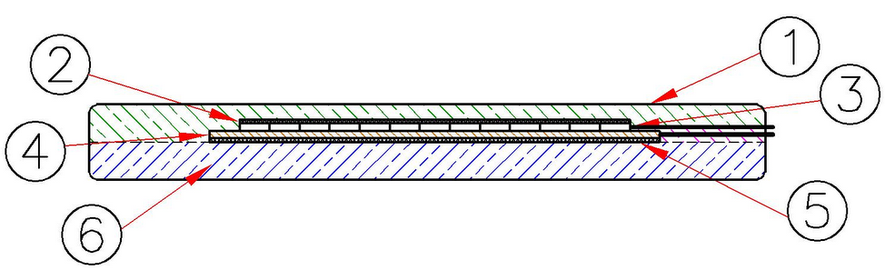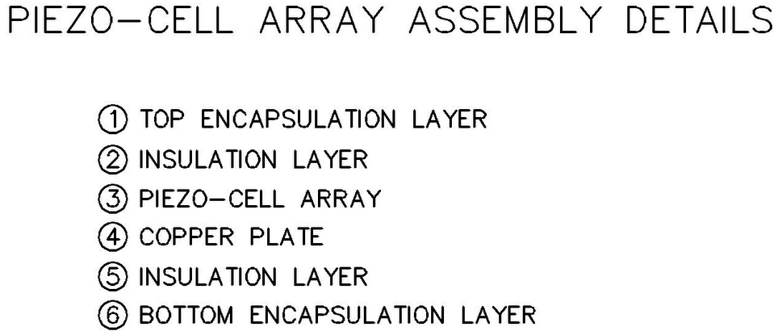

[5.1.2] Financial Analysis: Mass Production Model

Sr | COMPONENT | QTY | COST (INR) | TOTAL (INR)
1 | Piezoelectric Sensor Array | 2 | 300 | 600
2 | Encapsulating thermoplastic | 2 | 200 | 400
3 | Electronic Components | 1 | 195 | 195
 |  |  | TOTAL | 1195
 | DETAILS
1 | PIEZOELECTRIC SENSOR ARRAY
Copper plate base |  | 1 | 40 | 40
Ceramic Piezoelectric crystals |  | 8 | 30 | 240
Single core wire (0.5 metres) |  | 0.5 | 10 | 5
Electrical insulation tape(2m) |  | 1 | 15 | 15
 |  |  | SUBTOTAL | 300
2 | ELECTRONIC COMPONENTS
Input amplification circuit |  | 1 | 25 | 25
Microcontroller Atmega 8 |  | 1 | 80 | 80
Printed Circuit Board |  | 1 | 50 | 50
Single core wire (5m) |  | 4 | 10 | 40
 |  |  | SUBTOTAL | 195

Considering mass production, a 20% volume benefit is assumed:

The System Cost of 1 strip comes to Rs. 956/=

A total of 4 half lanes to be sensed:

= 956 * 4
= 3824

Rs. 3824 is the cost of a Complete Unit.

An additional Rs. 150 or so can be assumed in miscellaneous costs such as packaging

GRAND TOTAL: Rs. 4000 per unit- mass produced

